**Paratextual Material for Rumba**

Juliet McMains

mcmains@uw.edu

[mcmains@u.washington.edu](https://mail.uvic.ca/owa/redir.aspx?C=FjCrBc5ogUGNjxRmjLJkjIQws40isdAIQp6TeWWpUdFAXmJ8HdUtzMKdhopmMrjTEKCeYCT0G10.&URL=mailto%3amcmains%40u.washington.edu)

Websites:

Really great information on the music: <http://www.pbs.org/wgbh/latinmusicusa/#/en/exp/rumba/universe>

Images:

There are great images of Veloz and Yolanda inside this issue of Life and of course on the cover.

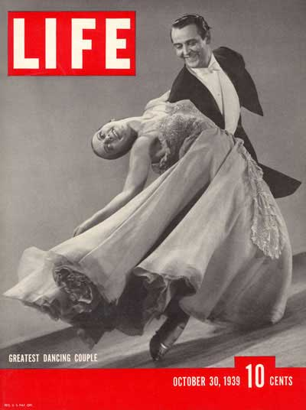

You can use this image of Doris Lavelle dancing while Pierre is playing the bongos. The image was given to me by Doris Lavelle’s nephew, Bruce Davis. 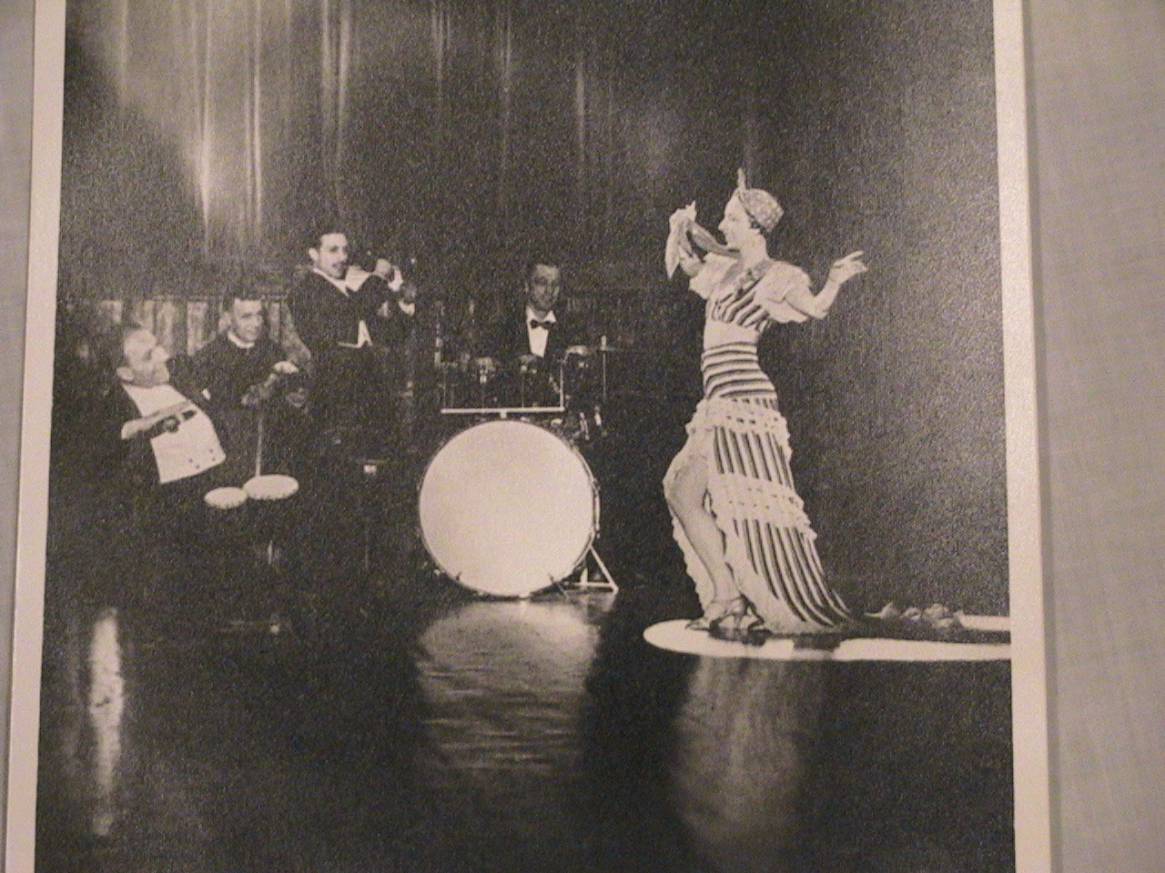

This is a great image of the munequitos, but I don’t know who owns it.

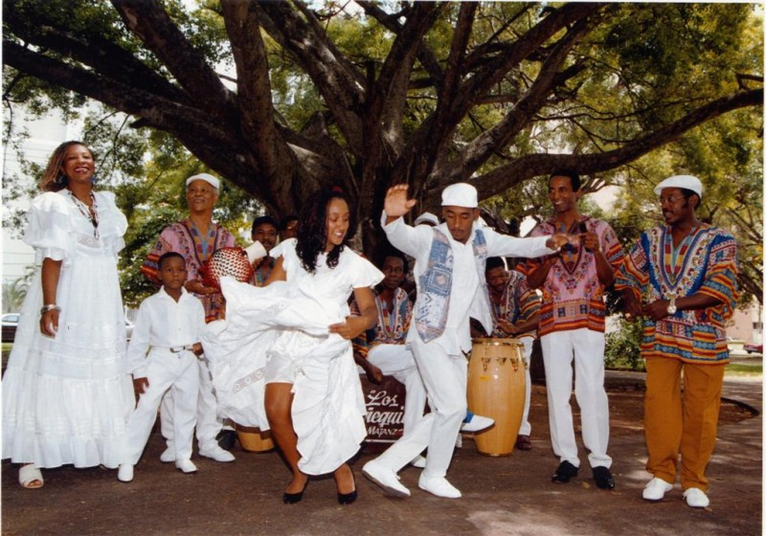

Video:

1) Veloz & Yolanda: perform as dance doubles for George Raft and Carol Lambard in the 1935 film Rumba. I have a copy. They also perform rumba in this clip, but I don’t know where it is from (the rumba starts at 7:45) http://www.youtube.com/watch?v=23Ctc9cYu34

2) Rene Rivera and Estella Ajon perform a son which is considered a rumba in the US in the 1939 film *Another Thin Man*.

http://www.youtube.com/watch?v=C0_ZMpEDFO4

3) For footage of the Munequitos, see Yvonne Daniel’s film *Cuban Rumba*, Insight Media.